Dovery Down Lower School

Homework Guidelines

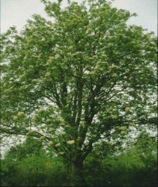  Reception/Rowan Class  Ongoing: Reading  Weekly: Alphabet letter bags/High frequency ‘Mr Happy’ word sliders.  Phonic packs sent home Autumn term.  Each week: Story sacks.  Spring term: Maths sacks.  Library books are changed independently by the child, during library time.  Handwriting/cutting practice when required.  Learning Journal goes home once a term with activity linked to topic.  Year 1/ Beech Class  Ongoing: Daily reading  Tuesday: Word Walls with Common frequency words to read and then spell and sound walls with phonic sounds.  Friday: Maths, homework given out to be returned by the following Friday to be marked.  Friday: Spellings given out to be tested the following Friday.  Extra topic based projects during holidays  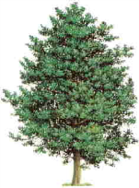  Year 2/ Holly Class  Ongoing: Daily reading  Wednesday: Word Walls  Friday: Homework given out to be returned by the following Thursday to be marked.  Friday: Spellings given out to be tested the following Friday.  Books are changed daily by the child when required.  Handwriting practice when required.  Optional Extra: Voluntary research based on the current topic.  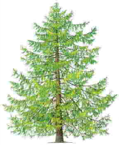  Year 3/Larch Class  Ongoing: Daily reading, x & ÷ tables practice.  Maths homework set Thursday each week, children given up to one week to complete.  Literacy: Half termly topic based project.  Friday: Spellings given out, to practise at home every day. Test on Friday.  Optional Extra: Voluntary research based on the current topic. |  |  |  |  | Year 4/ Oak Class  Ongoing: Daily reading,  x & ÷ tables practice.  Maths online homework set on a Friday each week, children given up to one week to complete.  Friday: Spellings given out, to be tested the following Friday.  Topic Based Project  Optional Extra: Voluntary research based on the current topic.  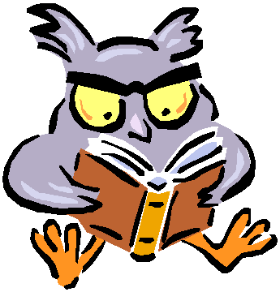
Year 4/ Oak Class

Ongoing: Daily reading,
x & ÷ tables practice.
Writing and Maths homework set on a Friday each week, children given up to one week to complete.
Friday: Spellings given out, to be tested the following Friday.
Topic Based Project
Optional Extra: Voluntary research based on the current topic.

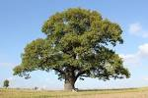

Spellings

In KS1 and KS2 children use the ‘Look, Cover, Write and Check’ method when completing their spelling grids. This is generally considered good primary practice. Children also take home a spelling book with their weekly spellings for learning at home. Children practice and learn their common exception words in class, and are tested termly.

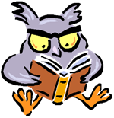

Updated 11/9/19

