**History**

Understand the Romans’ place in history and explore significant people and events of the Roman Empire.

Investigate life in Britain before and during the Roman occupation, including: the Celts and Boudicca’s rebellion; the Roman army; Roman food and entertainment; Roman engineering.

**French**

Weather words.

Classroom resources.

Names of fruit and vegetables.

**Computing**

Using computers to create written and visual displays linked to topic.

Using search engines and displaying results in a database.

Basic programming and algorithms.

**Geography**

Locate countries in Europe, name and locate towns and cities of the U.K.

Explore the geography of the UK and how it has changed since Roman times.

**Science**

States of matter.

Rocks and soils.

Working scientifically.

[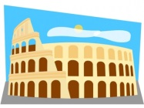](http://www.google.co.uk/url?sa=i&rct=j&q=&esrc=s&source=images&cd=&cad=rja&uact=8&ved=0ahUKEwj49uOf_ujOAhXDXRQKHTEjBYcQjRwIBw&url=http://clipart.me/free-vector/roman&bvm=bv.131286987,d.d24&psig=AFQjCNH-gbT0D-EsW0GWZrTgAyPVN1Y5tQ&ust=1472641221062732)[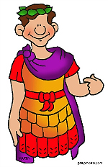](http://www.google.co.uk/url?sa=i&rct=j&q=&esrc=s&source=images&cd=&cad=rja&uact=8&ved=0ahUKEwjFqNHb_ejOAhVGPBQKHVclCcsQjRwIBw&url=http://www.history-for-kids.com/ancient-rome-for-kids.html&bvm=bv.131286987,d.d24&psig=AFQjCNGf3zplH3Ikv0BjO35U_wxS_jRilQ&ust=1472640950220715).

**English**

**Reading and Comprehension**

Reading, listening to and discussing a range of texts structured in different ways; preparing and performing poems and playscripts; retrieving and recording information from texts; identifying themes, drawing inferences and making predictions from details in the text.

**Spoken Language**

Participating in discussions, presentations, performances, roleplay/improvisations and debates; speaking audibly and fluently; using relevant strategies to build their vocabulary; using appropriate intonation and controlling the tone and volume so that the meaning is clear.

**Writing**

Writing descriptively and imaginatively using: similes, challenging vocabulary choices, synonyms, conjunctions, adverbs, prepositions, extending sentences with one or more clause, direct speech, paragraphs; using a dictionary and thesaurus; adding prefixes and suffixes to root words to change meaning; developing handwriting, spelling and use of appropriate punctuation.

**Maths**

**Addition and Subtraction**

Add and subtract amounts of money to give change, using both £ and p in practical contexts.

**Multiplication and Division**

Recall and use multiplication and division facts for the 3, 4 and 8 multiplication tables; calculate mathematical statements and solve problems involving multiplication and division, using materials, arrays, repeated addition, mental methods and multiplication and division facts, including problems in context; show that multiplication can be done in any order (commutative) and division cannot.

**Statistics**

Interpret and present data and solve questions using bar charts, pictograms and tables

**Measurement**

Measure, compare, add and subtract lengths, mass, volume/capacity. Measure the perimeter of simple 2D shapes. Tell and write the time from an analogue clock, including using Roman numerals from I to XII, and 12-hour and 24-hour clocks.

**Fractions**

Count up and down in tenths; recognise, find and write fractions of a discrete set of objects; recognise and use fractions as numbers; recognise and show, using diagrams, equivalent fractions with small denominators; add and subtract fractions with the same denominator within one whole; compare and order unit fractions, and fractions with the same denominators.

[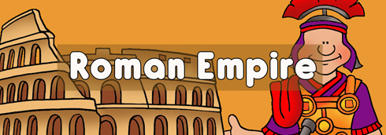](http://www.google.co.uk/url?sa=i&rct=j&q=&esrc=s&source=images&cd=&cad=rja&uact=8&ved=0ahUKEwjO_q-b_ejOAhUEwBQKHZNvDWUQjRwIBw&url=http://displays.tpet.co.uk/?topic%3DRomans&bvm=bv.131286987,d.d24&psig=AFQjCNGf3zplH3Ikv0BjO35U_wxS_jRilQ&ust=1472640950220715)

The Romans

[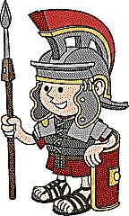](http://www.google.co.uk/url?sa=i&rct=j&q=&esrc=s&source=images&cd=&cad=rja&uact=8&ved=0ahUKEwiDsY3B_ejOAhWDUBQKHdymDVEQjRwIBw&url=http://www.history-for-kids.com/ancient-rome-for-kids.html&bvm=bv.131286987,d.d24&psig=AFQjCNGf3zplH3Ikv0BjO35U_wxS_jRilQ&ust=1472640950220715)

***Veni Vidi Vici***

[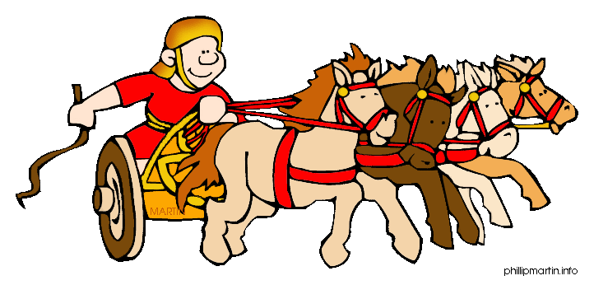](http://www.google.co.uk/url?sa=i&rct=j&q=&esrc=s&source=images&cd=&cad=rja&uact=8&ved=0ahUKEwiuo_bz_ejOAhVFshQKHZLhDM4QjRwIBw&url=http://rome.mrdonn.org/travel.html&bvm=bv.131286987,d.d24&psig=AFQjCNGf3zplH3Ikv0BjO35U_wxS_jRilQ&ust=1472640950220715)

**Summary of Work**

**Year 3**

**Spring 2019**

**PE**

Playing competitive games, applying basic principles suitable for attacking and defending. Developing flexibility, strength, technique, control and balance through dance.

**RE**

What do religions teach about the natural world?

Where, how and why do people worship?

**ART & DT**

Investigating and creating Roman artwork and mosaics.

Designing, making and evaluating a Roman shield and helmet.

**Music**

*Sing Out Play Out*

Learning a variety of songs culminating in a concert.