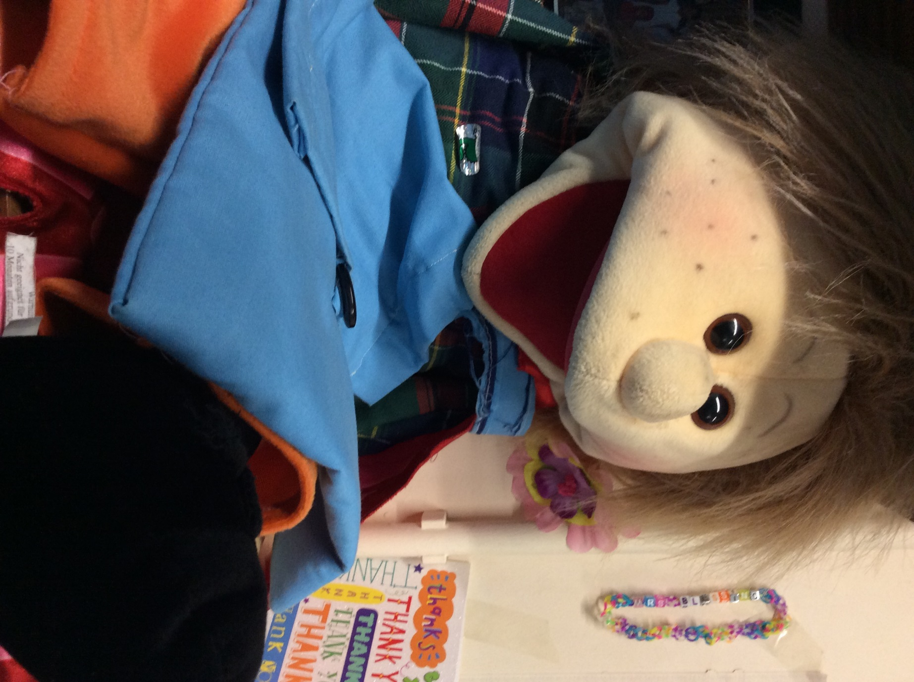

Hi...my name is BODO. I help the children to learn Phonics and I enjoy hiding objects in my satchel for the children to guess what they are. I help the children to learn how to sit and concentrate on the carpet during whole class learning time..

Meet our friends who help us in Rowan class.